Soccer Penalty game

EE-3921 011 Digital System Design

Final Project

Ziwei Chen and Zhaoming Qin

**Problem and Proposed Solution:**

The penalty game in soccer is always limited by its’ large field requirement, and the weather conditions. To eliminate all these specific requirements, a video game was developed using DE1 board and a VGA display.

Instead of two teams required in the traditional penalty, this game requires only two people to play as two teams. One as the goal keeper and another as the penalty taker. Each use three of the push buttons on DE1 board to make decision of which direction to go - middle, left or right. After both made the decision, animation will be played on the VGA display to show the penalty – just like what happened in the real game. The result will be shown for either goal or not by the animation.

**Preliminary Description of Hardware/Software Components**

**Description:**

This project requires a DE1 board and a VGA monitor, since a DE1 board offers 4 push buttons and only 3 required for each player, an external keyboard is not required. The software part will be written in C using *Nois II Software Built Tool for Eclipse*. A customized CPU will be created by using *Quartus* built-in *Qsys* software.

**Block Diagram:**

The following diagram shows the hardware setup for the system.



*Figure 1: Hardware System Setup*

**Flowchart:**

The flowchart for the C program was shown in the following diagram:



*Figure 2: Flowchart for C Program*

**Preliminary workload and assignments:**

The project can be divide into multiple assignments. The assignments were shown in the following table.

|  |  |
| --- | --- |
| ***Task Number*** | ***Task Name*** |
| ***1*** | *Costume CPU Implication Using Qsys* |
| ***2*** | *System Level I/O Interfacing Using Block Diagram* |
| ***3*** | *C Program Development Using Eclips (Game logic)* |
| ***4*** | *System Level verification and debugging (VGA output)* |
| ***5*** | *System Level verification and debugging* |
| ***6*** | *Final Project Demo* |

*Table 1: Preliminary Assignments*

**Preliminary Schedule:**

The following diagram shows the preliminary schedule for this project.

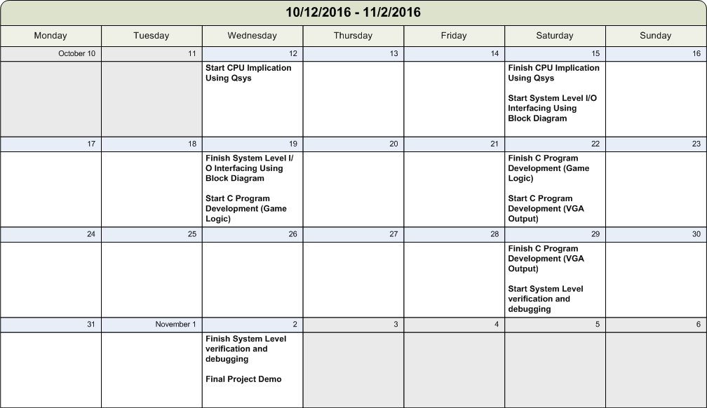

*Figure 3: Project Preliminary Schedule*